**Brandon Hobbs**

**May 1, 2023**

**CS-330: Module 1, Setup**

**Run the OpenGL with Updated Title**

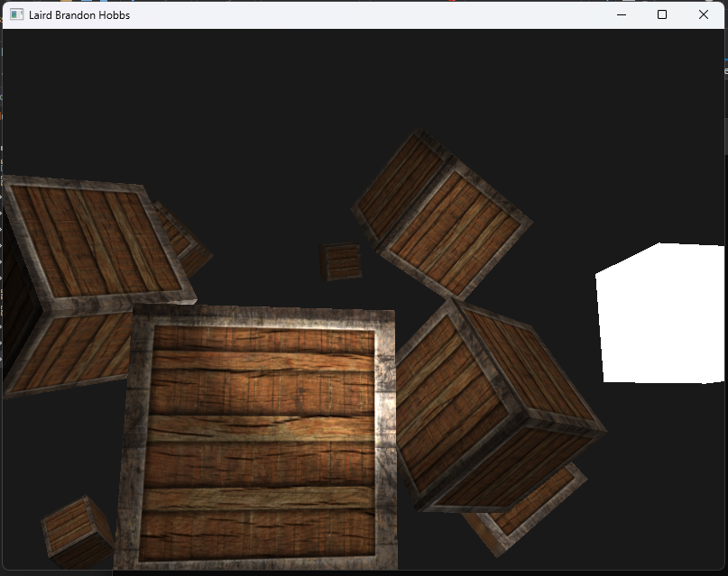

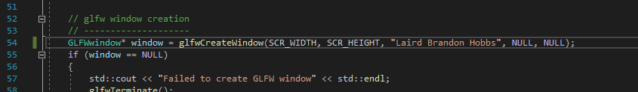

**Discuss Challenges**

The only challenge I faced was with using the Apporto VMs. Once I was able to execute the compiled EXE, I had to relocate all the files to the U-drive, the performance was too slow to be useful.  
  
I then reworked everything on my personal laptop and the sample ran quickly and well.